**Introduction**

**Method**

**Apparatus**

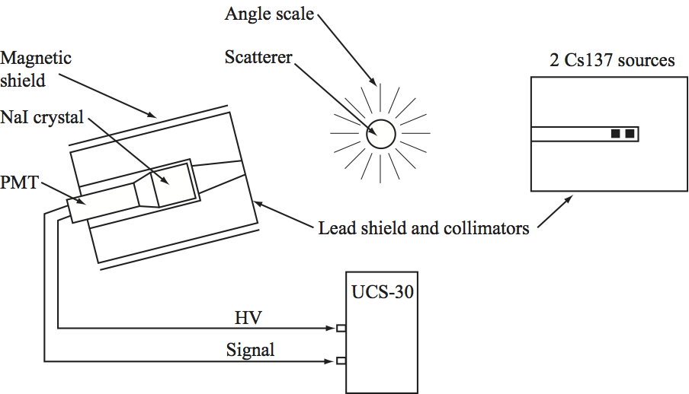

Figure 1: The experimental setup

Our setup consists of a pair of radioactive Caesium-137 sources housed in a radio-insulating box with a narrow opening. These produce gamma rays at 662 keV, which come out the opening as a collimated beam. The radioactive decay is directed at a cylindrical aluminum rod that scatters incoming photons at random angles – some energy loss is incurred. Finally, we have a NaI crystal and behind it a photomultiplier tube housed, again, in a radio-insulating box with a narrow opening that points at the scatterer. Each photon that strikes the NaI crystal will produce an output from the PMT. The size of the PMT pulses will be proportional to the energy of the photons that caused them. This signal is then sent to a PHA for quantification, and the data is then finally stored as a histogram on the computer. The PMT is mounted on a rail such that we can alter the angle between the PMT and the original sources without changing the distance from the PMT to the scatterer.

**Energy Calibration**

As mentioned earlier, the data from the PMT is stored as a histogram. However, our x-axis will need calibration, as the PHA will only know to assign higher energies to higher channel numbers. We do not calibrate directly on the PHA software, as we expect some drift to the (true) calibration throughout the experimental procedure. We use a 3-point calibration using the known energies, at the maximum angle of 135 degrees, of Ba-133 and Cs-137 peaks. The expected energies are calculated using